Learning about
GOVERNMENT PUBLICATIONS
doesn't have to be boring...
sooo have some coffee candy,
see what you think,
and........................

USES AND CHARACTERISTICS OF GOVERNMENT PUBLICATIONS
"Gov Docs" are a separate area of reference resources
because they have their own:
- classification schemes (su docs)
- departments and librarians (often)
- publishing company (the Government Printing Office (GPO) and other government entities, like the State of Kansas)

YET THIS INFORMATION IS USED BY EVERYONE
- It's authoritative
- It's comprehensive
- It's inexpensive (most websites are free!)
- It's easy to obtain (depository libraries)
Structure of Government
A Crash Course in American Government
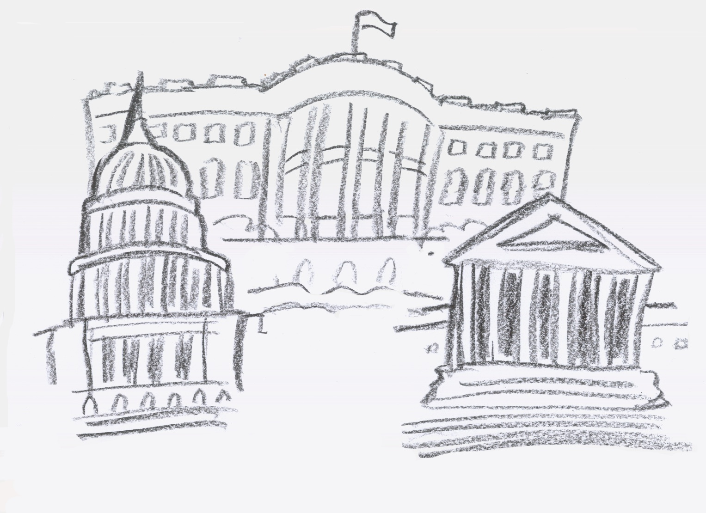

Three Branches of Government
Legislative -- makes the laws
Congress: House, Senate
- U.S. House of Representatives
  - http://www.house.gov/
- U.S. Senate
  - http://www.senate.gov/
- How A Bill Becomes a Law (Federal)
  - Text Version
    - http://www.vote-smart.org/resource_govt101_02.php
  - Simplest version
    - http://bullpup.lib.unca.edu/library/rr/images/billprocess.gif
  - Complex version
    - http://www.wand.org/images/bill-law.gif
  - Even more complicated version
    - http://senate.gov/reference/resources/pdf/legprocessflowchart.pdf
- Thomas (http://thomas.loc.gov/) (from the Library of Congress: http://www.loc.gov/)
- Bills and Laws
  - Bills, example: http://thomas.loc.gov/cgi-bin/bdquery/z?d110:h.r.01120:
  - Slip Laws, example: http://www.house.gov/house/laws.shtml#sliplaws
  - Statutes at Large, GPO database: http://www.gpoaccess.gov/plaws/index.html
  - U.S. Code, from the House: http://uscode.house.gov/
  - U.S.C.A., example, screenshot from Westlaw: http://homepage.mac.com/muswiz217/govdocs/uscawestlaw.jpg
- Committee & Subcommittee Hearing Records, Senate example,
  - http://hsgac.senate.gov/index.cfm?Fuseaction=Hearings.Detail&HearingID=437
- Committee & Subcommittee Reports, Senate example,
  - http://www.gpoaccess.gov/serialset/creports/katrinanation.html
- Congressional Record index
  - http://thomas.loc.gov/r110/r110.html
- Commissions created by Congress, the material they generate:
  - 9/11 Commission
    - http://www.9-11commission.gov/about/index.htm
Executive -- enforces the laws
President, Governor
- White House
  - http://www.whitehouse.gov/
- Agency publications, example
  - http://www.cdc.gov/nchs/products.htm
- Regulations, examples
  - Agency example
    - http://www.hhs.gov/ocr/hipaa/finalreg.html
  - Code of Federal Regulations (CFR) Index, from GPO
    - http://www.gpoaccess.gov/cfr/index.html
  - CFR, Annotated, example, from Westlaw
    - http://homepage.mac.com/muswiz217/govdocs/CFR.jpg
- Executive Orders, Current Administration (G.W. Bush)
  - http://www.whitehouse.gov/news/orders/
- Federal Register
  - Main Website, http://www.archives.gov/federal-register/index.html
  - Example of Issue, http://www.access.gpo.gov/su_docs/aces/fr-cont.html
  - Example of Page, http://edocket.access.gpo.gov/2007/E7-8097.htm
- Agency reports and analysis, example
  - http://www.usda.gov/wps/portal/!ut/p/_s.7_0_A/7_0_1UH?navid=FARM_BILL_ANALYSIS&parentnav=FARM_BILL_FORUMS&navtype=RT
- Agency research, example
  - http://www.ars.usda.gov/is/AR/index.html
Judicial -- interprets the laws
Supreme Court, Appellate Courts, District Courts; state court system
- Supreme Court
  - http://www.supremecourtus.gov/
- Case Opinions -- Case Law;
  - Search Archives, 1937-1975 (search here to find the Brown v. Board opinion text that was highlighted in class)
    - http://www.access.gpo.gov/su_docs/supcrt/index.html
  - Judicial Resources from GPO Access
    - http://www.gpoaccess.gov/judicial.html
- Case Dockets
  - http://www.supremecourtus.gov/docket/docket.html
Statistics
- Statistical Abstracts
  - Electronic Home
    - http://www.census.gov/compendia/statab/
  - Archive
    - http://www.census.gov/prod/www/statistical-abstract-1995_2000.html
- From Agencies, example
  - http://www.cdc.gov/nchs/fastats/older_americans.htm
FOIA (Freedom of Information Act)
- Explanation, from Dept. of Education
  - http://www.ed.gov/policy/gen/leg/foia/foiatoc.html
Organization of Documents
or
SU DOCS! (Superintendent of Documents Systems)
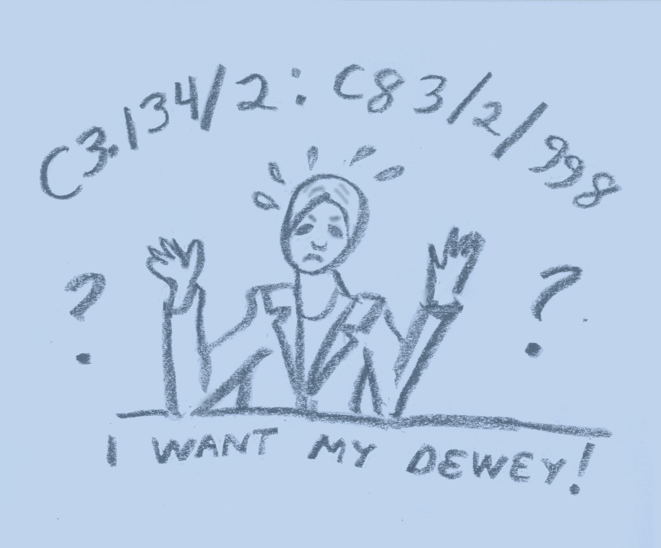
don't be blue, it's not that bad
The Superintendent of Documentation System is assigned by the GPO.
It uses the ISSUING AGENCY as its starting point (Dewey Decimal classifies by SUBJECT).
For instance:
C3/134/2:C83/2/998
C (Department of Commerce) + 3 (Bureau of the Census)
=C3. The ISSUING AGENCY is the Census Bureau, which is located in the Department of Commerce.
134 = title (Statistical Abstract of the United States)
2: = supplement
C83/2/ = refinement of title (County and City Data Book)
998 = 1998 edition
A Su Doc Primer: http://www.lib.msu.edu/publ_ser/docs/student/Manual/quizes/sudocsbasics1.html

Evaluation/Selection

Gov Docs are unique--
- No one else has the information (e.g. 2000 Census)
OR
- The publishing agency is the authority ( United States Geological Survey)
OR
- Information is produced in only one format (Toxic Release Inventory on CD-Rom)

But... Sometimes other publishers repackage the information
- Different formats
- Enhance the data
- Add special features like indexing, links, cross-referencing, or advanced searches
These options have to be weighed along with user needs, space available, and (ahem) budget.
Depository Libraries
- There are fifty regional depository libraries which receive everything the GPO produces.
- Each congressional district has at least two depository libraries which receive a core collection and various selected items.
- Other libraries also select items for their collection based on category and need.
- Depository libraries can be public, academic, or special libraries.
Find a depository library near you: http://www.gpoaccess.gov/libraries.html
Important General Sources
The best source for GPO output: http://www.gpoaccess.gov/index.html
A good site for (federal) legislative information: http://thomas.loc.gov/
The Federal Library: http://www.loc.gov/
Agency Websites
Federal Level
- USA Gov (http://www.usa.gov/): The federal government portal. A great starting place to find lots of online government documents
  - Directory to Federal Agency Websites
    - http://www.usa.gov/Agencies/Federal/All_Agencies/E.shtml
  - Directory to State Government
    - http://www.usa.gov/Agencies/State_and_Territories.shtml
  - Directory to Local Government
    - http://www.usa.gov/Agencies/Local.shtml
  - Directory to Tribal Government
    - http://www.usa.gov/Government/Tribal_Sites/index.shtml
- Department of State
  - http://www.state.gov/
- Department of Defense
  - http://www.defenselink.mil/
- Department of Agriculture
  - http://www.usda.gov/
- Department of Education
  - http://www.ed.gov/
- Department of Homeland Security
  - http://www.dhs.gov/index.shtm
- Health and Human Services
  - http://www.hhs.gov/
- The White House
  - http://www.whitehouse.gov/
- The Supreme Court
  - http://www.supremecourtus.gov
- The U.S. Senate
  - http://www.senate.gov/
- The House of Representatives
  - http://www.house.gov/
State Level (Kansas used as the example)
- Kansas Government
  - http://www.kansas.gov/government/
- Agency Website Listing
  - http://www.kansas.gov/government/agency_listing.html
  - Department of Administration
    - http://www.da.ks.gov/
  - Attorney General
    - http://www.ksag.org/home/
  - Secretary of State
    - http://www.kssos.org/
    - Publications section
      - http://www.kssos.org/pubs/pubs.html
  - Department of Revenue
    - http://www.ksrevenue.org/
- Kansas Legislature
  - http://www.kslegislature.org/legsrv-legisportal/index.do
- Kansas Courts
  - http://www.kscourts.org/
- Kansas Governor
  - http://www.governor.ks.gov/
Government Websites for All

For children, students, and young adults...
- Ben's Guide to the U.S. Government for Kids (sponsored by the GPO) (http://bensguide.gpo.gov)
  - This website introduces students and teachers to the GPO and how to use its resources.

- CIA's Homepage for Kids (https://www.cia.gov/cia/ciakids/index.shtml)
  - Top secret, encrypted site to find out what the CIA is and what it does.
  - Where else would you find about the CIA Canine Corp or find out about the CIA seal?
- FEMA for Kids (http://www.fema.gov/kids.html)
  - Herman the spokescrab wants to help kids learn what causes disasters, play games, read stories, and become a Disaster Action Kid!

- Ready Kids--Dept of Homeland Security--Really! (http://www.ready.gov/kids/)
  - A clever game helps kids remember what to pack in an emergency kit. Help making a "just in case plan for the family, and lots of hints for teachers and parents, too!

- Federal Deposit Insurance Commission: FDIC's Learning Bank (http://www.fdic.gov/about/learn/learning/index.html)
  - What is the FDIC? Have you ever thought about what a bank does with your money? Do you know what a bank account is? What about a savings account? Carmen Cents, the animated piggy bank will lead children through entertaining lessons.

- U.S. Consumer Product Safety Commission: 4 kids: (http://www.cpsc.gov/kids/kids.html)
  - Do you know what the single dumbest thing you can do when riding a bike is? Take the brain buster quiz and learn--(hint, it's not wearing your helmet!)

- The White House for Kids (http://www.whitehouse.gov/kids/)
  - Helping young people to become more active and informed citizens is the stated purpose of this site. That's true, but don't miss the great pictures of Barney and Miss Beazley! Lots of history available too!

- NASA--Kids Home (http://www.nasa.gov/audience/forkids/home/index.html)
  - This site has a lot of fun information, but you really have to check out what the best-dressed astronauts wear!
- U.S. Environmental Protection Agency: Explorer's Club (http://www.epa.gov/kids)
  - All aspects of the environment are talked about with great links to topics of interest such as the Chesapeake Bay Program
  - Games, Pictures, Stories and Activities for many ages!

For those of us who are older ...
- Nutrition.gov (http://www.nutrition.gov/index.php?mode=homepage)
  - Information on the food pyramid, a calorie counter, recent articles dealing with food safety--it's all here on a website sponsored by the U.S. Dept. of Agriculture (http://www.usda.gov/).

- Science.gov (http://www.science.gov/)
  - The gateway to over 1800 scientific websites, this is the search engine for government science and research information. This site will even set up e-mail alerts when new research in your area of interest becomes available.

- National Archives and Records Administration (http://www.archives.gov/)
  - The online exhibit hall gives digital access to important national documents and a wealth of other information including World War II photos, military records, and the Presidential Library System.
Guides
Print:
Morehead, J. (1999). Introduction to United States Government Information Services, (6th ed.). Englewood, CO: Libraries Unlimited, Inc.
- Revised every four years
- Easy to read and use
- Clear explanations of departments and agencies
Schwarzkopf, L. (1972 to date). Government Reference Books. Englewood, CO: Libraries Unlimited, Inc.
- Published every two years
- Arranged by broad subject, then author and title
American Library Associations Government Documents Round Table (GODORT)
- Selective list of government documents for small- to medium-sized libraries
- Published annual in May in Library Journal
Electronic:
- GOVDOCS-L listserv, discussion about government documents and the Federal Depository program
  - http://govdoc-l.org/
Catalogs and Bibliographies
Online:
- GPO Access, Government Printing Office Online Portal
  - http://www.gpoaccess.gov/index.html
- Catalog of U.S. Government Publications
  - http://catalog.gpo.gov/F
  - While a print version still exists, its arrangement is by classification number. It's much easier to use the online version and search by keyword, subject, or author. Two thousand titles are added monthly.
- GPO Online Bookstore
  - http://bookstore.gpo.gov/
Search Strategies
- Use website search engines
- Email or telephone (consult print or Web agency directory for specialist in field)
- Contact Legislator's office (not most expedient method)
- Visit Depository libraries
  - http://www.gpoaccess.gov/libraries.html
Note: All original artwork by Dian Hauser.

Created by Heather Braum, Dian Hauser, Jan Brooks, and Joleen Kapka, for LI 813 at Emporia State University, School of Library Information Management, Spring 2007, contact with questions at govdocsli813@mac.com

